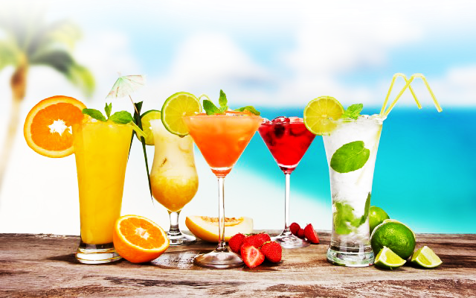

**Book your cocktail party by calling 01702476 999 or visit** [**www.thamesbreeze.co.uk**](http://www.thamesbreeze.co.uk) **for more info**

**Bar-Restaurant- Events**

**Cocktail Menu**

Cosmo £7.50

Fresh Lime Juice – Cranberry Juice -Cointreau -Vodka

***

Mohijo £7.50

White rum, Fresh Mint, Soda Water, Fresh lime juice, Sugar

***

Sex on the Beach £7.50

Vodka, Cranberry Juice, Peach Schnapps & Orange Juice

***

Espresso Martini £ 7.50

Vodka, Kahlua, espresso shot & topped with coffee beans

***

Aperol Sprits £7.50

Prosecco, Aperol, Soda & Garnish

***

Pornstar Martini £8.50

Vodka, Passion Fruit Puree, Orange Juice, Caster Sugar, Garnish – served with prosecco champagne

***

Black/ White Russian £8.50

Coffee Liqueur and Lots of Vodka / Fresh Cream for White Russian

***

Lemoncello Spritz-£8.50

Prosecco, Lemoncella, Soda & Garnish

*Please ask for any cocktails that are not listed